Ideation Phase
Define the Problem Statements

Date | 25 February 2026
Team ID | LTVIP2026TMIDS81684
Project Name | Calculating Family Expenses using ServiceNow
Maximum Marks | 2 Marks

Customer Problem Statement Template:
Create a problem statement to understand your customer's point of view. The Customer Problem Statement template helps you focus on what matters to create experiences people will love.
A well-articulated customer problem statement allows you and your team to find the ideal solution for the challenges your customers face. Throughout the process, you’ll also be able to empathize with your customers, which helps you better understand how they perceive your product or service.

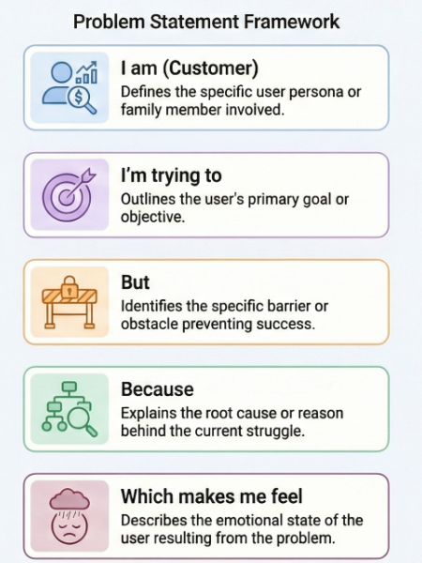
Reference: https://miro.com/templates/customer-problem-statement/
Example:

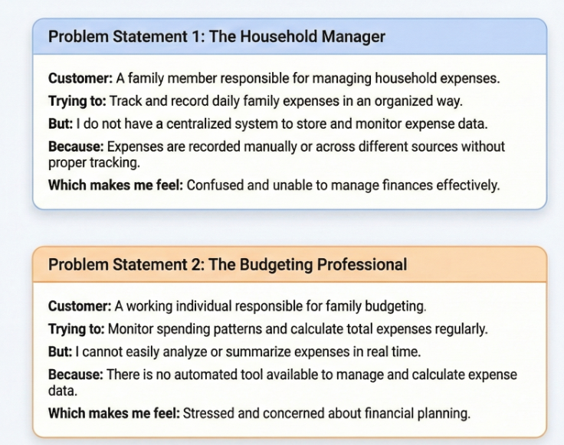

Problem Statement (PS) | I am (Customer) | I’m trying to | But | Because | Which makes me feel
PS-1 | A family member responsible for managing household expenses | Track and record daily family expenses in an organized way | I do not have a centralized system to store and monitor expense data | Expenses are recorded manually or across different sources without proper tracking | Confused and unable to manage finances effectively
PS-2 | A working individual responsible for family budgeting | Monitor spending patterns and calculate total expenses regularly | I cannot easily analyze or summarize expenses in real time | There is no automated tool available to manage and calculate expense data | Stressed and concerned about financial planning

